**Name Cameron Willis**

**Python Activity 1: Introduction to Python**

|  |
| --- |
| **Learning Objectives**  Students will be able to:  *Content:*   * Explain how to display data in Python * Explain how to create a comment in Python * Determine the difference between a *string literal* and a *number*   *Process:*   * Create **print** statements in Python * Create *Python* code that displays results to calculated addition facts * Discuss problems and programs with all group members   **Prior Knowledge**   * Be able to input and execute Python code using the Python IDE |

**Critical Thinking Questions:**



1. Enter the Python program shown above. What does it do?

It puts the text Go! On the line below. _________________________________________________________________________________

|  |
| --- |
| **FYI:** A **"string literal"** is a sequence of characters surrounded by double quotation marks (" "). |

1. Type and execute following code. What output is produced? Indicate if there is a problem.
   1. print(“Hello, my name is Pat!”)

Hello my name is pat is put onto the line below

* 1. print(Hello, my name is Pat)

you get an error that says “Syntax error perhaps you forgot a comma?”.

* 1. print(“Hello.\nMy name is Pat”)

It says “Hello”. Drops down a line and then says “my name is pat”

1. What caused the different output format for samples “a” and “c” in question 2?

The \n tells python to go to the next line

4. What do you think the following Python statements output? Enter the statements in the interactive mode of the Python interpreter to verify your answers.

* 1. print(2+5) 7
  2. print(2*5) 10
  3. print(“2+5”) 2+5
  4. print(“Age:”,20) Age: 20

1. Examine the output for each statement in question 4.
   1. What is the difference in the output for the statements in “a” and “c” of question 4?

The quotes change the numbers for int to str. So c prints the quote of 2+5 while a adds them together.

* 1. What caused the difference?

The quotation marks.

* 1. Which statements contain a *string literal*?

C

* 1. What does the comma (,) do in the print statement in part “d” of question 4? How does it affect the spacing of the output?

Adds exactly one space between Age: and 20

* 1. Examine the following code and its output. What do the first three lines of the program do?

Nothing as they are now comments indicated by the # before the text.

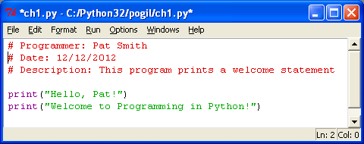

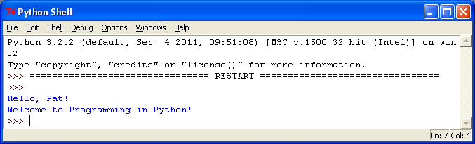

**Output**



1. What would happen if you placed a “#” in front of the code: in the previous program?

The text would turn red but would not execute because now it’s just a comment.

**Application Questions: Use the Python program mode to design and check your work**

1. Create a Python program containing three statements to print the following output. Write the statements below.

print("Congratulations!\nyou just created \nyour first Python program")

1. 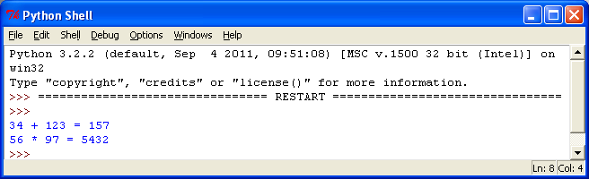Create a Python program containing two statements that prints the output to the right. *Have the program calculate the answers to the two arithmetic problems.*print(('34 + 123 ='), (34+123), ('\n56 * 97 ='), (56 * 97))